TALK: THE MAKING of ‘THE GREATEST MENACE’
Time: Mar 17, 2022 05:00 PM Canberra, Melbourne, Sydney Starts 5.30.pm – 7.00

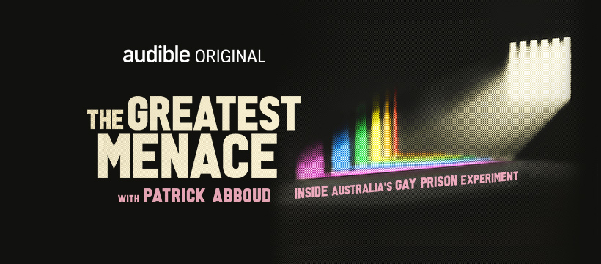

INFO and BOOKING FOR LIVE EVENT
John Woolley Common Room, 4th Flr. UNI SYDNEY
https://www.eventbrite.com.au/e/the-making-of-the-greatest-menace-tickets-288950457597

REMOTE ZOOM LINK:
Join from PC, Mac, Linux, iOS or Android:
https://uni-sydney.zoom.us/j/88529591003?pwd=dlBuYytxeGpjOXdzVWNNZGR0ZDZDUT09
Password: 346192

Or iPhone one-tap :
Australia: +61731853730,,88529591003# or +61861193900,,88529591003#
Or Telephone:
Dial(for higher quality, dial a number based on your current location)：
Australia: +61 7 3185 3730 or +61 8 6119 3900 or +61 8 7150 1149 or +61 2 8015 6011 or +61 3 7018 2005
Meeting ID: 885 2959 1003
Password: 346192
International numbers available: https://uni-sydney.zoom.us/u/kbkgbLlOuK

Or an H.323/SIP room system:
Dial: 88529591003@@zmau.us
or SIP:88529591003@zmau.us
or 103.122.166.55
Meeting ID: 88529591003
Password: 346192
Or Skype for Business (Lync): https://uni-sydney.zoom.us/skype/88529591003

