REGISTRATION FORM
ECU Logo ???

ABN 54 361 485 361
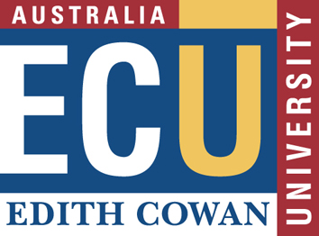

Exploding Media Myths: Misrepresenting Australia? Workshop
20 November 2008, University of New South Wales, Sydney. ABN 54 361 485 361
Exploding Media Myths: Misrepresenting Australia? brings together those who create the stories, those who make policy, those who manage public opinion and those who have been affected by media reporting, in a public debate about the power of the media and its impact on our lives.
Section 1: Personal Details
Title (Mr/Mrs/Ms/Dr/Prof)
Last Name:
First Name:
Preferred First Name (for name badge):
Position:
Organisation:
Postal Address:
Suburb/Town:................................................. State:
Country:.................................................. Post Code:
Tel:........................................... Fax:
Mobile:
Email:

Registration is free and includes tea/coffee on arrival, morning and afternoon tea and lunch.

Section 4: Special Dietary or Mobility Requirements
Please advise any special dietary or mobility requirements:

Fax Form to: +61 (0)8 9370 6073
Post Form to: Mrs Linda Jaunzems
Forum Administrator
Faculty of Education and Arts
Edith Cowan University
2 Bradford Street
Mt Lawley Western Australia 6050.

Email Form to: explodingmediamyths@ecu.edu.au

Further information:
Website: http://www.explodingmediamyths.org.au
Email: explodingmediamyths@ecu.edu.au
Phone: 0419 964 219

